# PROGRAM

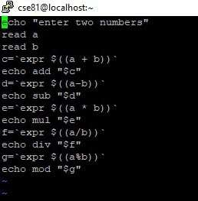

|  |  |  |
| --- | --- | --- |
| EXP NO:2a | SHELL SCRIPT | Aryan Sai Venkat M  CSE A 230701040 |

# OUTPUT

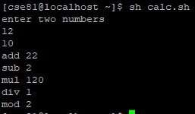

# EXP NO:2b

## PROGRAM

1

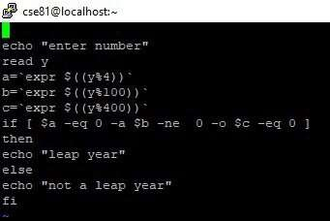

## OUTPUT

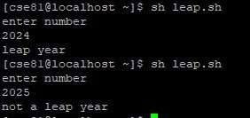

2